NON-METAL SLUDGE SCRAPER

- Designed and fabricated according to ANSI standard.
All non metal sludge scrapers are designed and fabricated according to ANSI, American
National Standards Institute, standard, and are compatible to existed sludge scrapers
Installed.

- Green materials are selected.
100% recyclable materials are applied. The products completed their duration are not
classified as industrial biomass. Our material is a 100% recyclable.

- No so many spare parts stocked required.
The sprockets which request to purchase so many spare parts in case the axis diameter
of initial and secondary settling tank is differ from each other do not request purchase
so many spare parts in our system, because the diameter of our sprocket is changed
by inserting of a simple adapter. This means that a separate stock of spare parts is not
required.

- No effected by each chain type
Each part of this sludge scraper will be easily compatible to each axis diameter and chain
type such “ pintle “ and “ loop “ chain. The important parts of product are designed to be
replaceable and compatible to different products.

NON-METAL SLUDGE SCRAPER

A. Introduction of main parts
DRIVEN SPROCKET
MAIN CHAIN
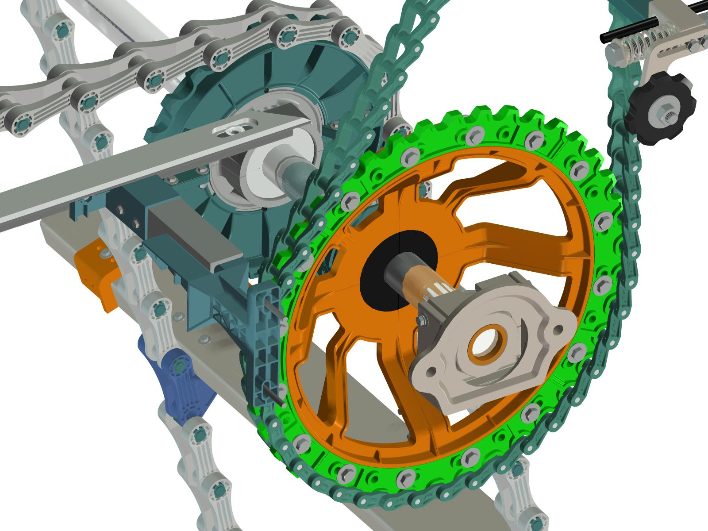
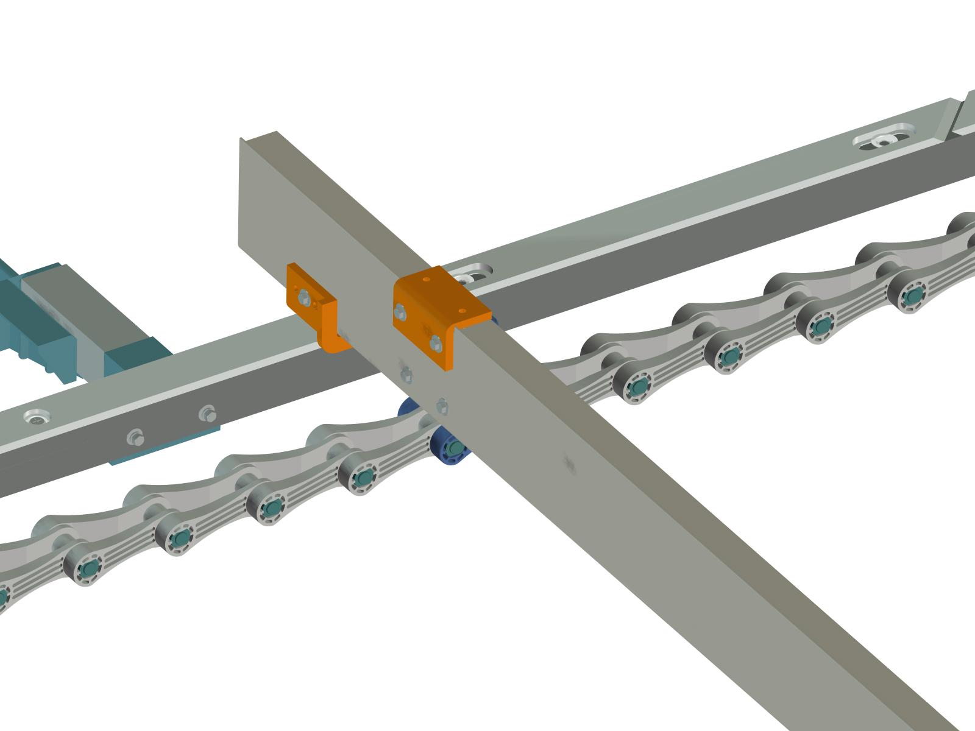

IDLE SHAFT & SPROCKET
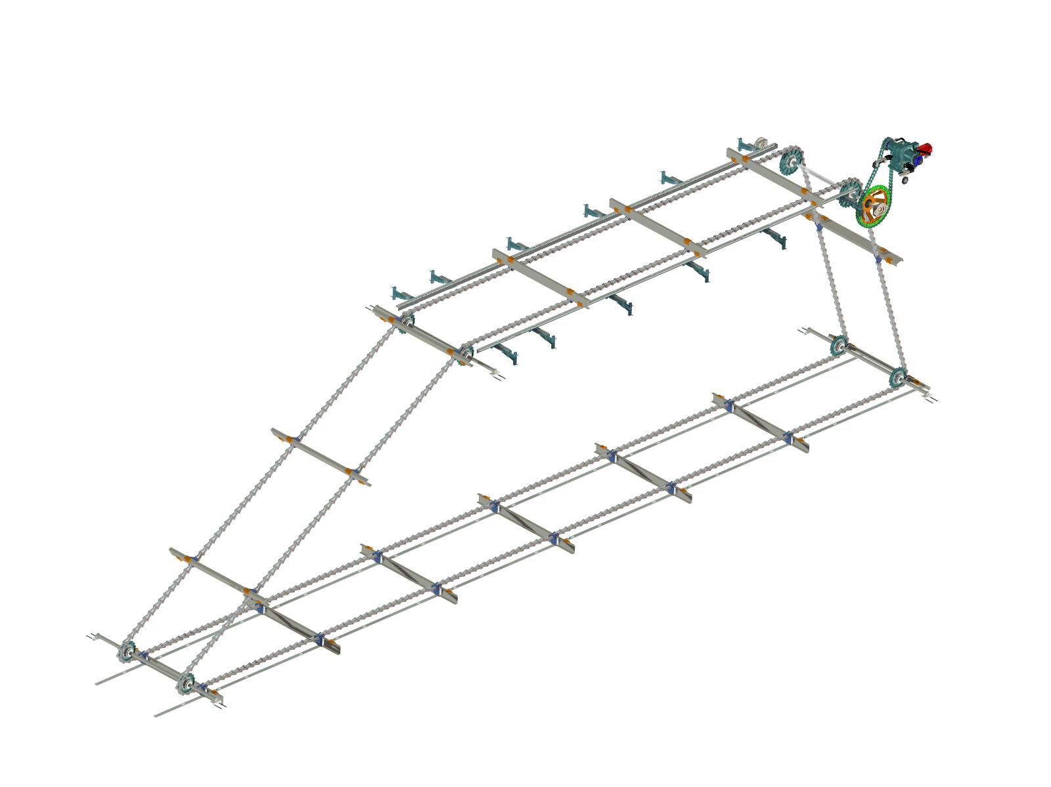
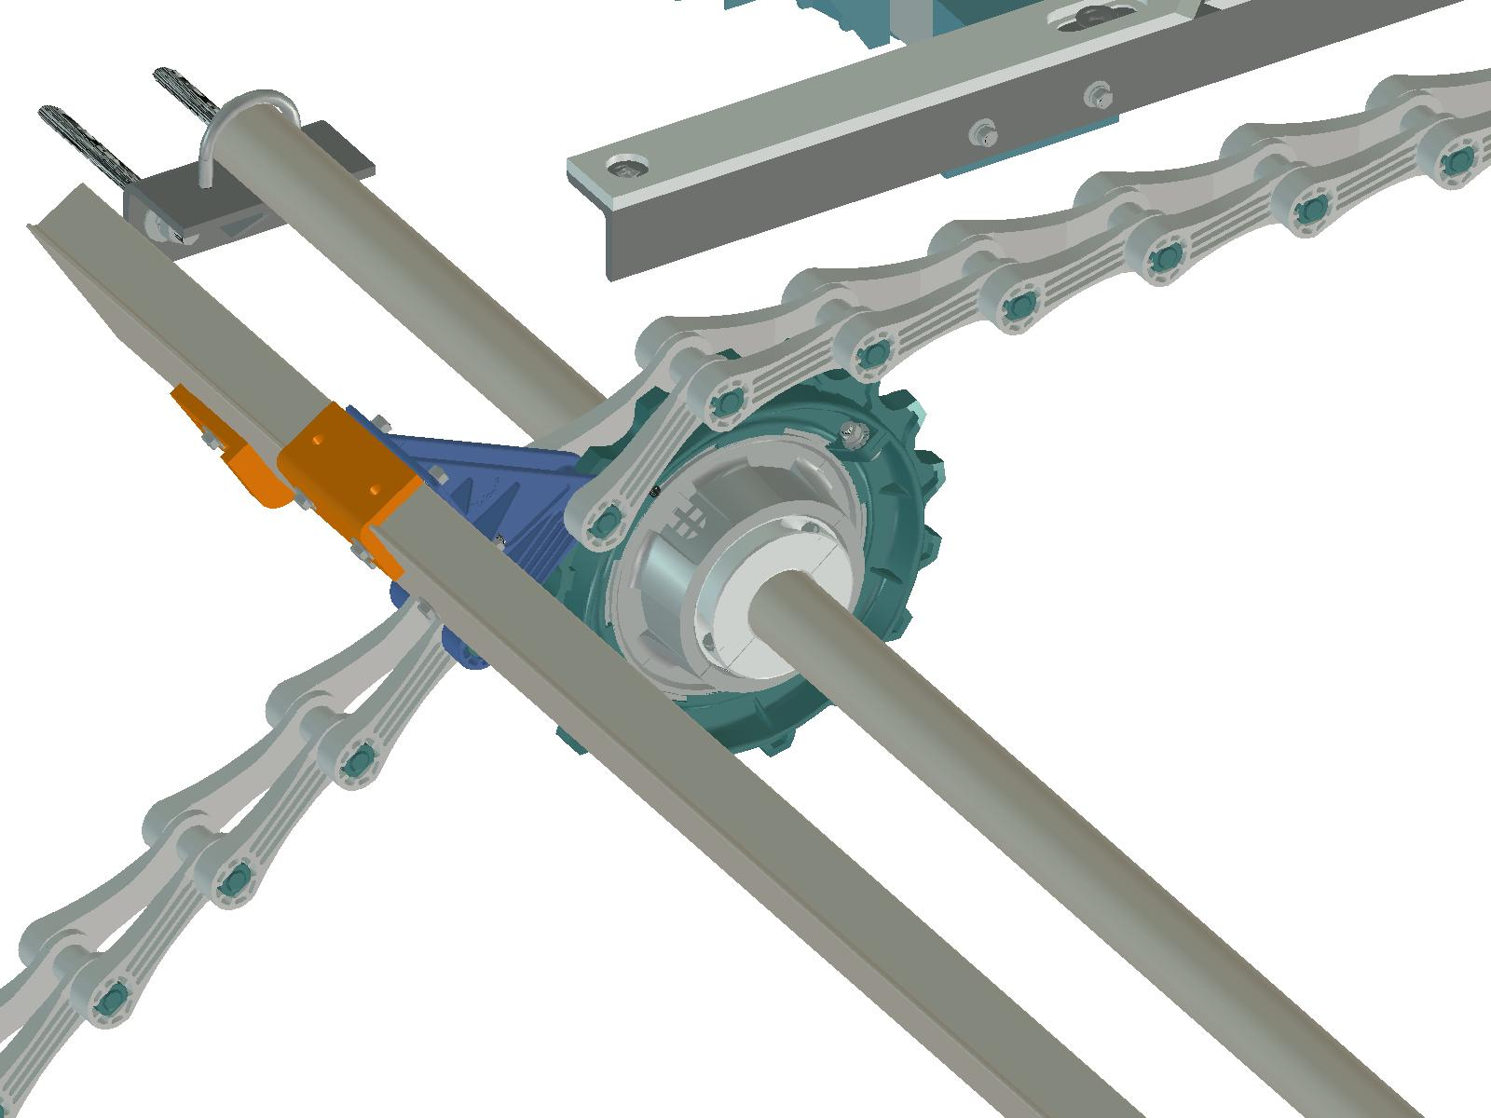
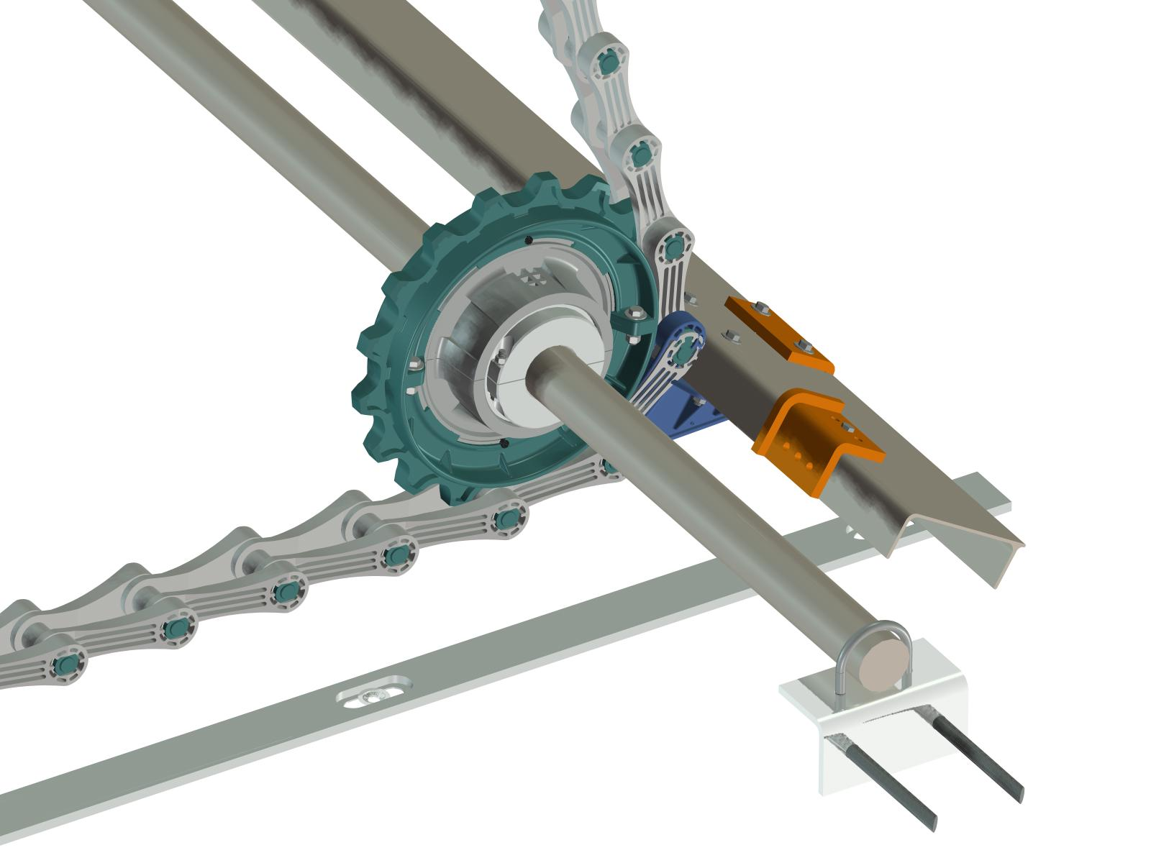
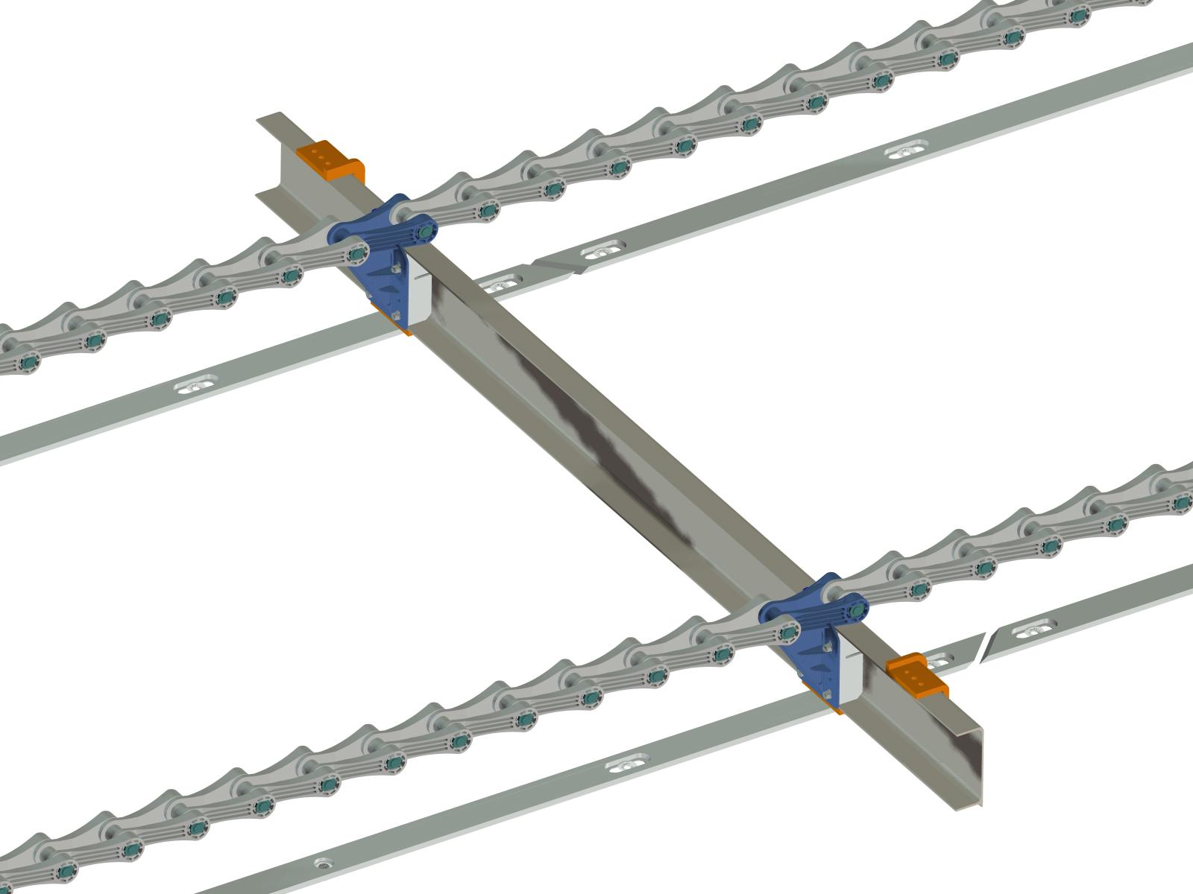
CONER SHAFT & SPROCKET
FLIGHT & SHOE

NON-METAL SLUDGE SCRAPER

a. Collector chain

Collector chain will be composed of barrel and link as an incorporated type. The collector
chain will be made of high strength PET. The chain will be consisted of main body chain
link and chain pin, fixed pin, and a couple of jaw. When the fixed pin will be inserted
to the inside of chain pin, the couple of jaw will be extended so that the chain pin will
prevent the breakaway of body chain. This structure will make the separation of chain
easily and prevent the damage of sludge scraper from breakaway of chain pin.

Collector chain will be made of polyethylene terephthalate, PET, thermoplastic resin,
so that the collector chain will have a proper endurance and recycling.
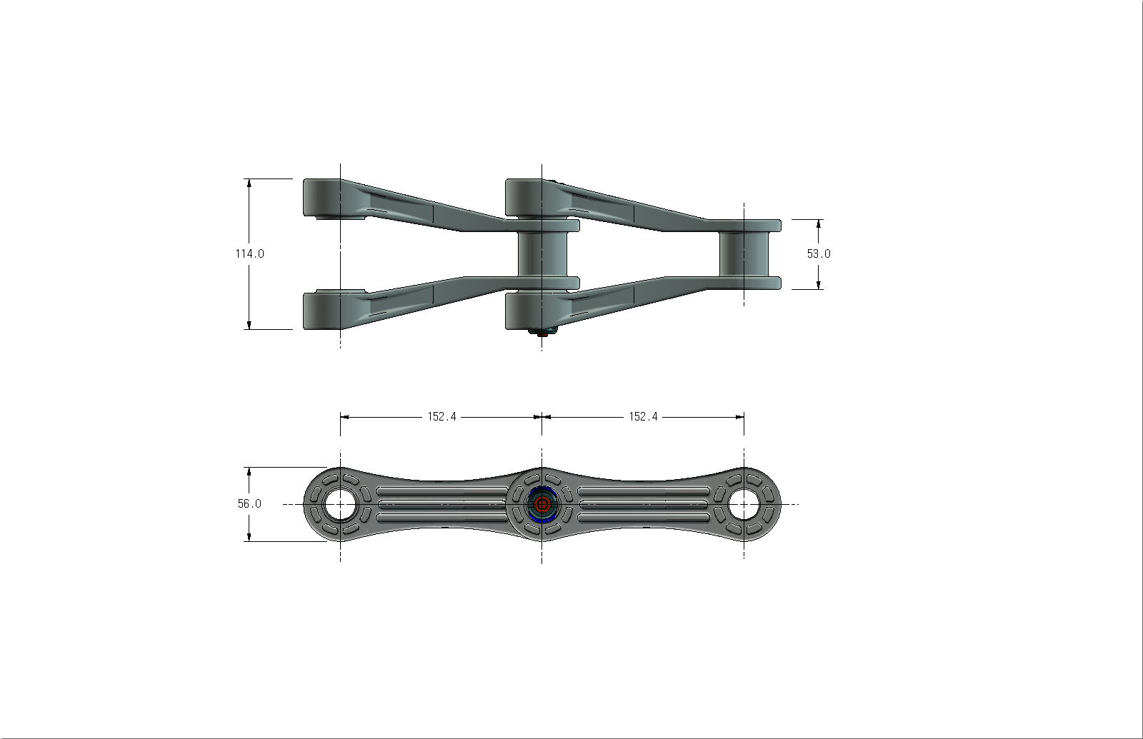
The pitch of chain 152.4mm
, as per international standard
of ASME.
Chain pin will be made of
Polyamide and produced
by injection molding.
The attachment will be
assembled with flight will
be a incorporated type,
which will not by separated
to chain and will be made of
polyethylene terephthalate, PET.

Flight will be produced the type of 150mm according to standard required.

Part  No | Pitch mm (in.) | Working Load  N (Kgf.) | Average Ultimate Strength  N  (Kgf.) | Weight (kg./m.) | Barrel |  | Pin |  |  | Side Bar
 |  |  |  |  | Outside  Dia.  D (mm.) | Witch W (mm.) | Outside Dia.  d (mm.) | Material | Length L (mm.) | Height H (mm.) | Inside Width L1 (mm.)
 |  |  |  |  |  |  |  | Poly  -amide | Length L (mm.) | Height H (mm.) | Inside Width L1 (mm.)
LKSC-  CS720 | 152.4 (6") | 19,610  (2,000) | 39,200  (4,000) | 2.2 | 22.8 | 34 | 22.5 | Poly  -amide | 114 | 56 | 53

NON-METAL SLUDGE SCRAPER

b. Flight
The bottom contacting area of flight will be molded by scraper rip for the effective
removing of sludge. A filler block will be inserted between flight and attachment to
exactly set the flight to chain attachment.

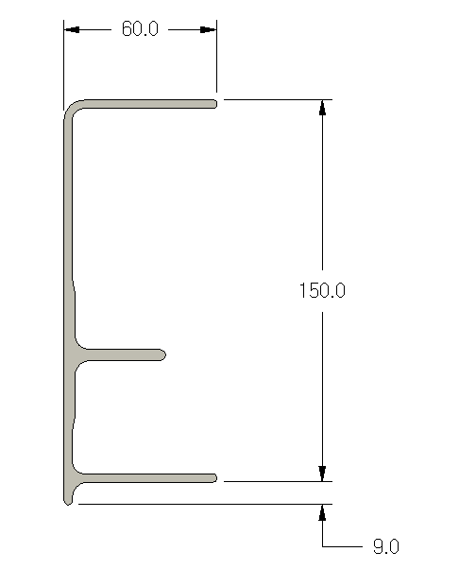
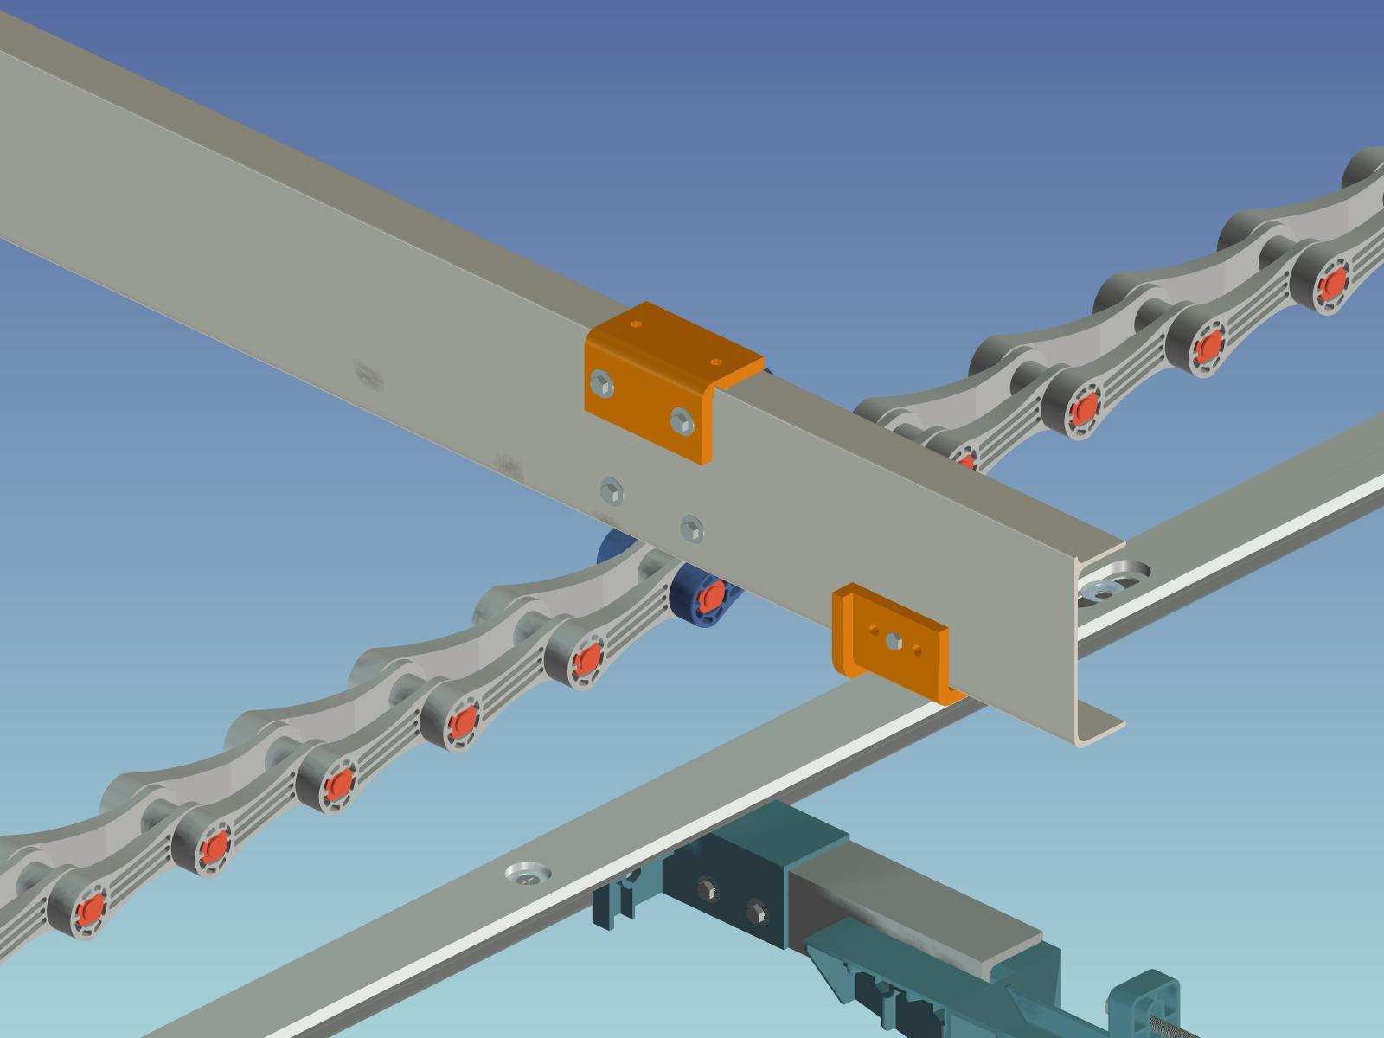

.

The flight will be produced by aluminum extruding and the cross section of flight will be
“E” type to receive and feed the sludge load well. The height and width of flight will be
150mm and 60mm and an anti corrosion coating will be added.
Part Number | Product | Material | Weight  (Kg./m.) | Height  (mm.) | Depth  (mm.) | Max length (m)
LKSC – FT100 |  | Aluminium(AL)  Or  FRP |  | 150 | 60 | 6.0

c. Shoe (Return & carry)

Each wearing shoe, 12mm thickness, will be assembled to each flight to prevent the
abrasion of flight during rail and return track running. The wearing shoe will be a proper
material having a enough rust resistance to assure the maximum endurance.

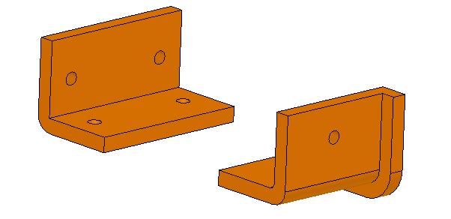
Each flight will be consisted of a set of return shoe and a set of carrier shoe. Return and carrier shoe will
two wearing sides at the both sides and in case a side
will be worn out, the other side will be used. The shoe will be set by stainless steel bolts.

NON-METAL SLUDGE SCRAPER

The return shoe will have a “ L “ type rise foam, 12mm, and will be produced at 76mm of
height, 76mm of width, and 114mm of length. Carrier shoe will be produced at 76mm of
height, 76mm of width, and 140mm of length.
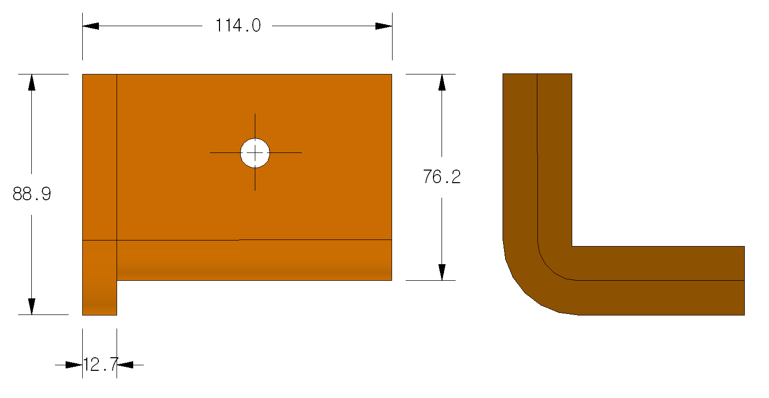
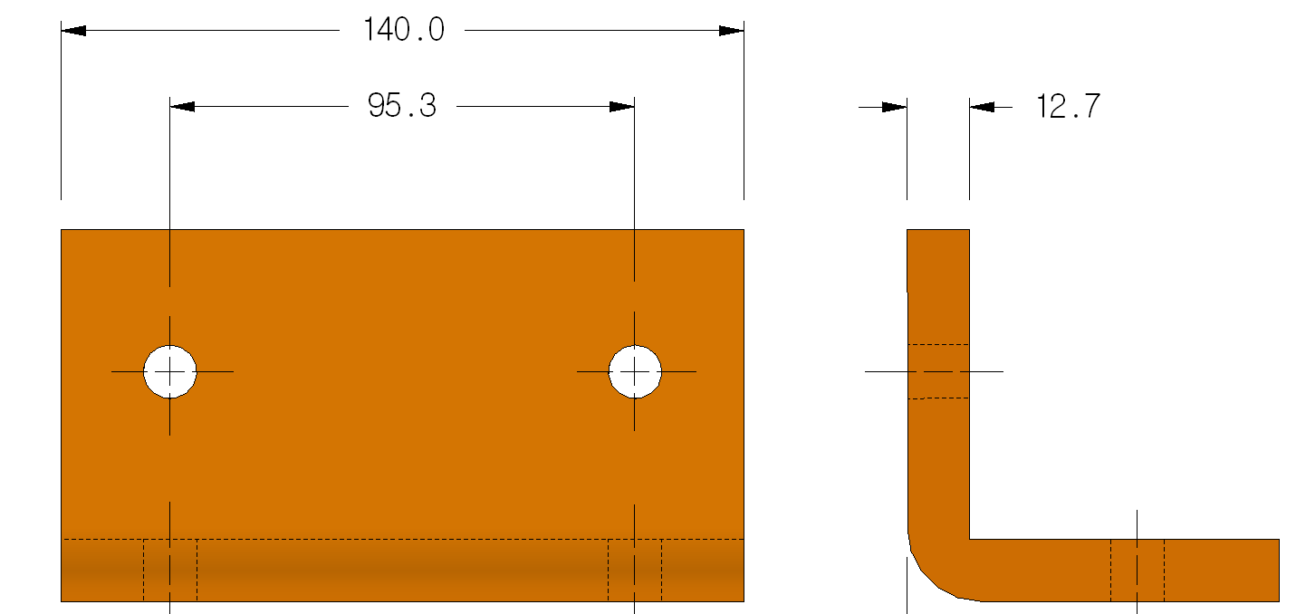
d. Head sprocket and idle sprocket

Head sprocket and idle sprocket will be consisted of a adapter, a herb and a sprocket
body. Head sprocket and idle sprocket will be a half split type and will be tightly
structured by stainless steel bolts. The adapter of sprocket body and herb will be
made of nylon, as half split type.

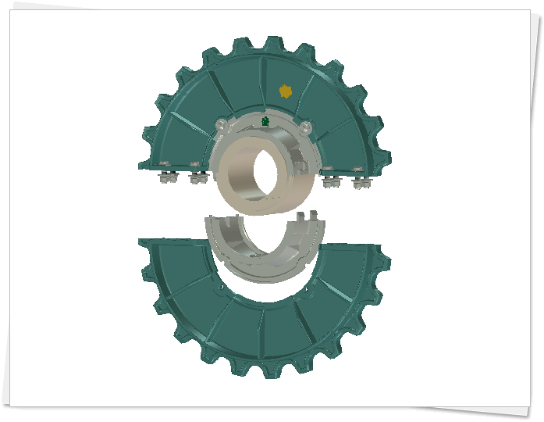
The assembly of sprocket body will be
conducted by T shape rail which foamed
on herb.
When sprocket herb will be worn out,
it will be easily replaceable by the
separation of sprocket body from the herb.
Head sprocket body will be also
replaceable by idle sprocket body,
because head sprocket body will be
compatible to idle sprocket body.
The adapter in herb will be assembled
by head shaft and non metal key.

A save rim has been molded, as one body and consists with main chain on the around
sprocket tooth, will resist enough to sludge load with abrasion of sprocket at whole
area of main chain during the operation and the sludge load will be uniformly
distributed to the sprocket. The sprocket tooth and herb will be made of thermoplastic
terephthalate (PET).

NON-METAL SLUDGE SCRAPER

The sprocket tooth will be 23 NT and structured as a double life type according to ANSI
standard.

Part No | Tooths | Chain  application | Material | Pitch mm (in.) | Dimension |  | Bolt
 |  |  |  |  | Outside | Inside
 |  |  |  |  | Dia.D | Dia.D | R. x mm. | Q'ty
 |  |  |  |  | (mm.) | (mm.) | R. x mm. | Q'ty
LKSC-SP210 | 17 Tooth | Idle- pintle | Polyamide | 152.4 (6") | 421.88 | 276 | M10 x 40L | 8
LKSC-SP310 | 23 Tooth | Head- pintle | Polyamide | 152.4 (6") | 564.6 | 276 | M10 x 40L | 8
HUB | 9 ~ 23 Tooth  / Pintle, Loop combination |  | Polyester |  | 276 | Ordered  manufacturing |  | 4

e. Sleeve bearing

The sleeve bearing will be assembled on idle shaft and corner shaft. It supports the
smooth rotation of shaft and sprocket during the rotation of sprocket and releases the
abrasion of sprocket to increase duration. The sleeve bearing, rotating and contacting
directly sprocket, will be made of high density polyethylene which has a high sliding
friction and rust resistance to endure frictional wear during intermittent operation.

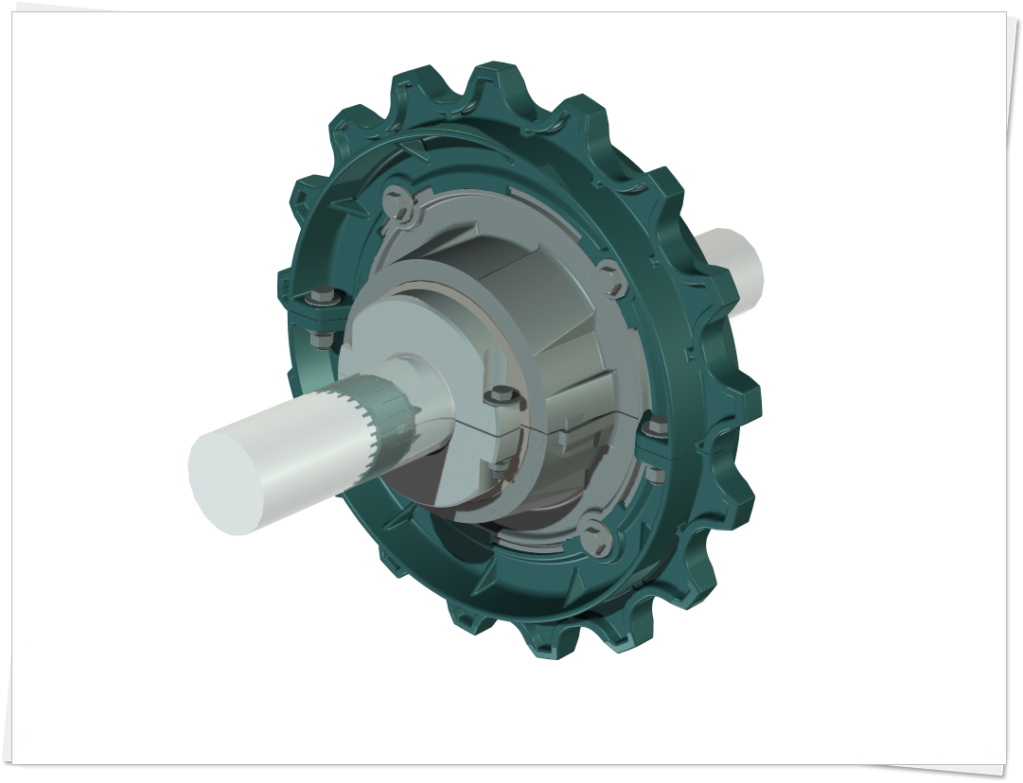
For easily replacement from
excess wearing, the sleeve
bearing will be split by 2 parts
and will be fixed to shaft by
stainless bolts.

The sleeve bearing will be
also a thermoplastic material
and the parts over the life
will be recycled.

NON-METAL SLUDGE SCRAPER

h. Driven sprocket
The driven sprocket will be
consisted of sprocket and
body, clamp, and adapter.

The sprocket delivering the
force of driving chain will be
a type of NH78, 40T and
structured by 4 split parts.
It will be made of
high strength nylon.

Sprocket body will be made
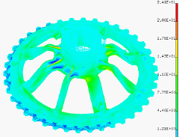
of high strength nylon and
structured by 4 split parts for easy replacement without disassembly of shaft.

The clamp will fix body, adapter, and shaft.
The clamp will be a split type and will form
variable shaft diameters to be compatible any
sized shaft diameters.
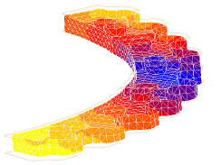

The whole parts will be made of high
strength thermoplastic material and
any items over the life will be
recycled.

Part No | Description | Material | Pitch mm (in.) | Dimension |  | Piece | Bolt
 |  |  |  | Outside | Inside | Piece
 |  |  |  | Dia.D | Dia.D | Piece | R. x mm. | Q'ty
 |  |  |  | (mm.) | (mm.) | Piece | R. x mm. | Q'ty
LKSC-SP100-02 | Tooth | Polyamide | 66.27(2.609") | 844.6 | 762 | 4 Piece | M16 x 80L | 16
LKSC-SP100-01 | Body | Polyester |  | 762 | 210 | 4 Piece | M12 x 50L | 8
LKSC-SP100-03 | Clamp | Polyester |  | Inside 210 |  | 2 Piece | M10 x 45L | 4

NON-METAL SLUDGE SCRAPER

i. Drive chain

The drive chain which delivers driving force from reducer to driven sprocket will be
manufactured according to NO. 188, the regulation of chain, ASME. The chain will
offset type chain and will be made of high strength thermoplastic nylon resin.

The connection pin of link will be assembled with grinded stainless steel pin and will
endure working loads enough.
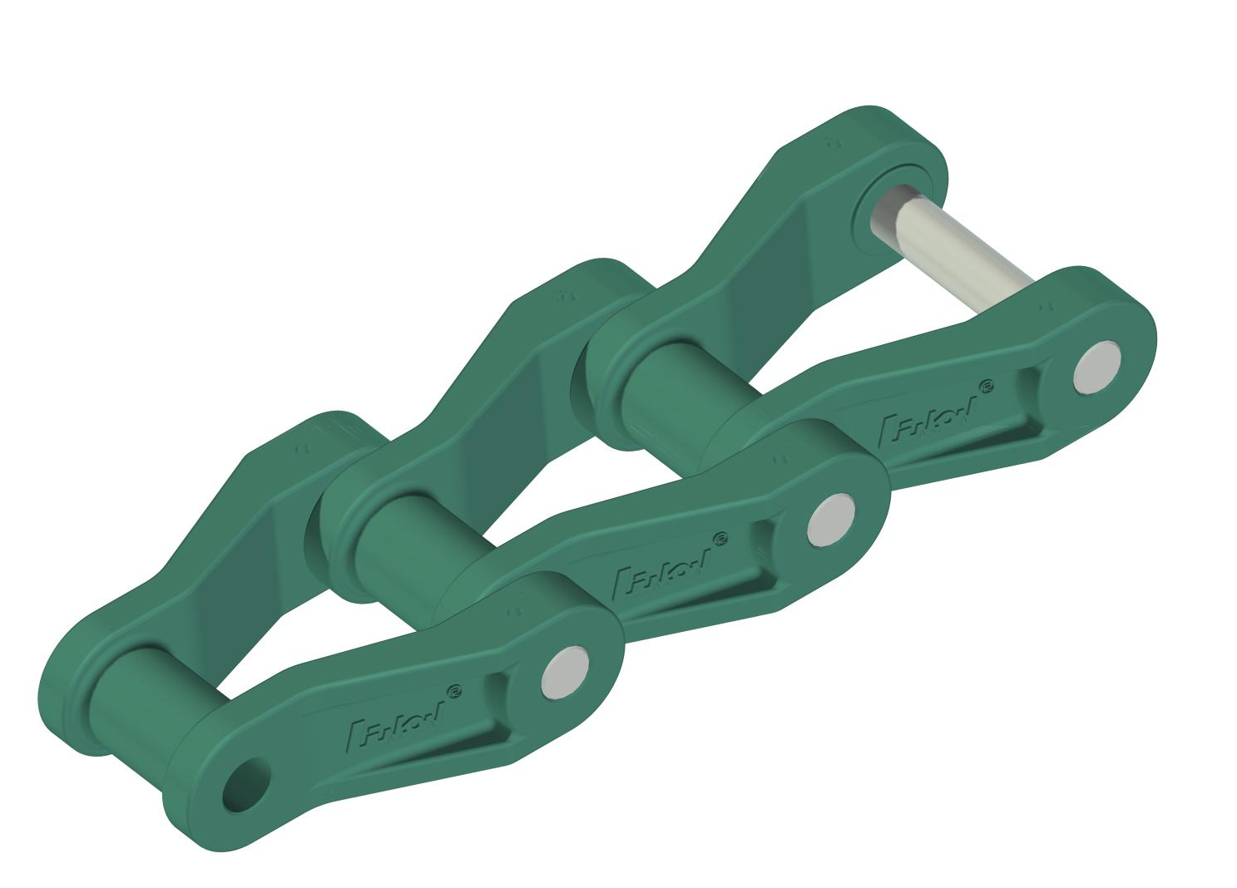
- Type : NH-78 Chain
- Pitch : 66.27mm
- Material : High strength thermoplastic
nylon resin
- Working loads : 7,845N (800kgf)

j. Drive sprocket

In case of overloads, drive sprocket will cut off driving power by shear pin. In case of
overload, the sensor pin inserted in the sloped hole of inside sprocket will rise and strike
the limit switch to make alarm. In case of wearing out, it can be re-used by rotating of pin
by 180 ° meaning it has been manufactured two sides symmetry.

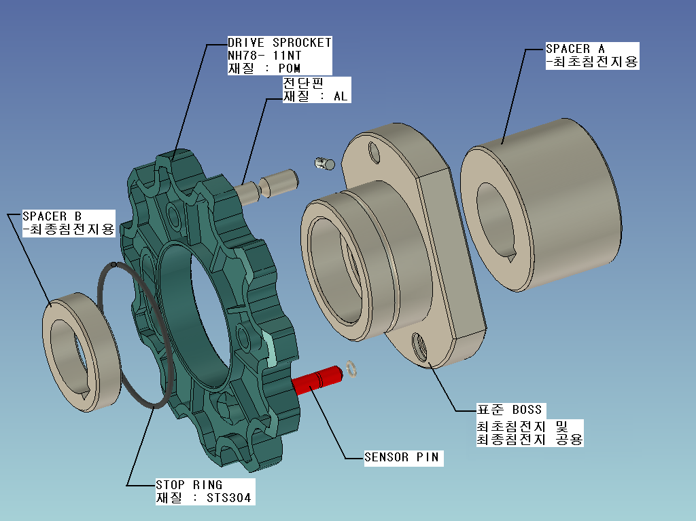
Sprocket and boss will be fixed by stainless
snap ring, which do not request any specific
bolt and assembling parts to assure easy
assembly and disassembly.

Shear pin will be made of uniform quality
aluminum and be a V-neck type to exactly
detect the overload.

The sprocket will be made of high
strength thermoplastic nylon or thermoplastic polyacetal. The sensor pin will be made of
engineering plastic, polyacetal, excellent self lubricated.

NON-METAL SLUDGE SCRAPER

To avoid a protrusion of sensor pin by vibration during the operation of sludge scraper,
an O-ring will be inserted in the center of sensor pin.

- Type : NH-78 11NT
- Material : High strength thermoplastic nylon or polyacetal
- Manufacturing method : Injection molding

k. Jaw clutch

The jaw clutch assembled with drive sprocket will cut off or connect the driving force from
each settling tank for easy maintenance of each settling tank. Independent operation of
scraper on each settling tank will be available by jaw clutch application.

In case of overloads, the driving force will be cut off by safety pin. The abnormal cut of
safety pin will be detected by the protrusion of sensor pin. And this will be sensed by limit
switch.
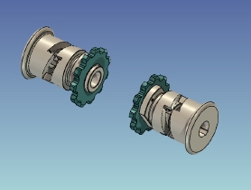
Sprocket and boss will be fixed by stainless
snap ring, which do not request any specific
bolt and assembling parts to assure easy
assembly and disassembly.

Shear pin will be made of uniform quality
aluminum and be a V-neck type to exactly
detect the overload.

The sprocket will be made of high
strength thermoplastic nylon or thermoplastic polyacetal. The sensor pin will be made of
engineering plastic, polyacetal, excellent self lubricated.

To avoid a protrusion of sensor pin by vibration during the operation of sludge scraper,
an O-ring will be inserted in the center of sensor pin.

- Type : NH-78 11NT
- Material : High strength thermoplastic nylon or polyacetal

NON-METAL SLUDGE SCRAPER

- Boss : Nylon
- Jaw clutch : Nylon
- Shear pin : Aluminum
- Sensor pin : Polyacetal

l. Return bracket & wear pin

(1) Return bracket
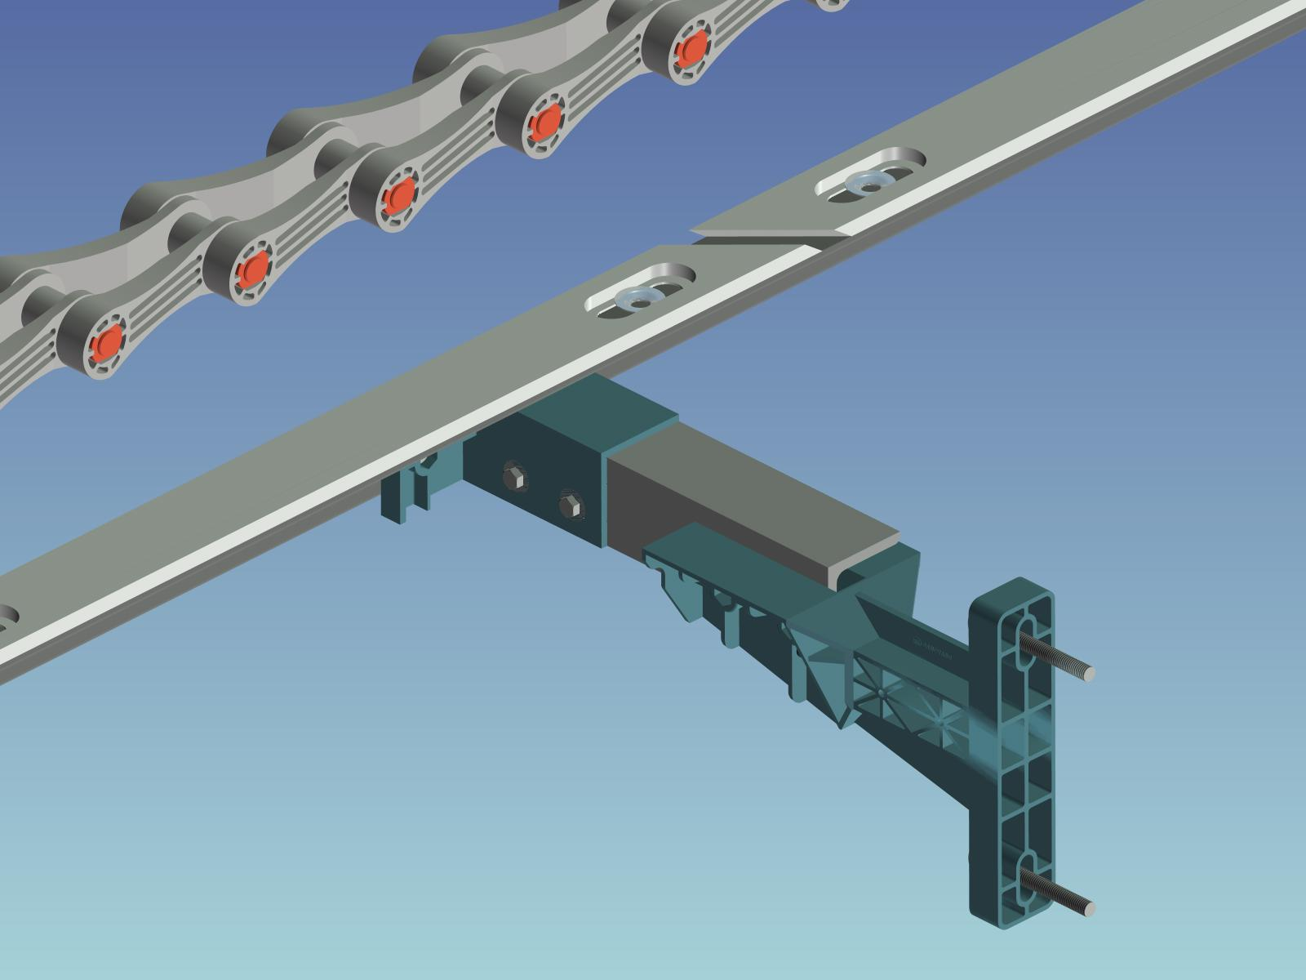
Return bracket will be consisted of
angle, 75 x 75 x 9t, which will be
adjusted by the length of bracket
body and bottom of settling tank,
and T arm, which connected to
return rail. The length of return
bracket will be adjusted enough
by main body and arm length.

Bracket body will be made of
thermoplastic polypropylene, recyclable. T-arm will made of FRP extruded
or aluminum.

(2) Wear strip
Wear strip will be consisted of return and
carrier wear strip. Wear strip will be made
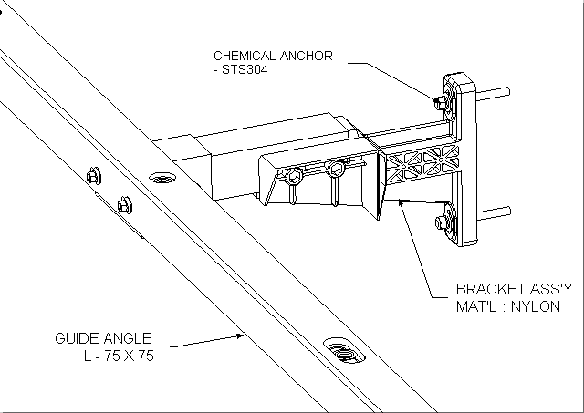
of HDPE, high density Polyethlene.

Return wear strip with return bracket
will in installed near by water surface
to support flight which will move to the
direction of skim skimmer.

Carrier wear strip will be strictly fixed on
the bottom of settling tank using stainless
corn washer and vinyl cap anchor.

